**Lesson 03 Class Assignment**

**Note: If there are any graphs used, please paste your results in this assignment.**

1. Did you attend class today (4 pts)?
2. Were you on time to class (2 pts)?

**Work in a Group on this problem.** The following are the ages of the Quorum of Twelve Apostles and the First Presidency of the Church of Jesus Christ of Latter-Day Saints:

61, 63, 64, 65, 65, 71, 75, 75, 76, 83, 84, 84, 87, 89, 92

1. Calculate the five-number summary of the ages of these general authorities (2 pt).

**Min = 61 Q1=65 Median=75 Q3=84 Max=92**

1. For **only** the general authorities aged 64, 70, 82 and 88 calculate (not using SPSS) the standard deviation of the four ages by hand (using only those four numbers to calculate) (2 pt).



1. Use the class survey data and use the guesses of Brother Cromar’s age (Title: age). Complete the following questions

* 1. Find the Mean, Median, Standard Deviation, Variance of the guesses of Brother Cromar’s age (2 pt.).

**Mean=47.429 Median= 47 SD=7.499 Variance=56.234**

* 1. Find the five-number summary of the guesses of Brother Cromar’s age (2 pt.)

**Min = 21 Q1=43 Median=47 Q3=52 Max=79**

* 1. Create a boxplot and a histogram of the guesses of Brother Cromar’s age (3 pts.)

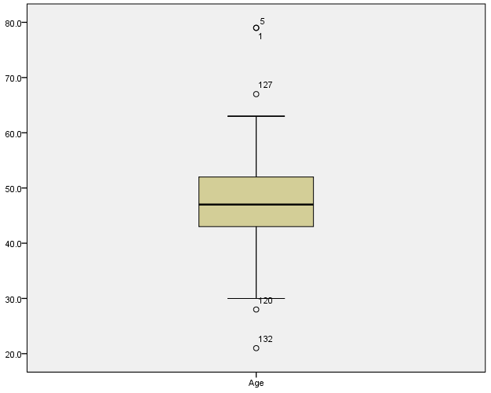

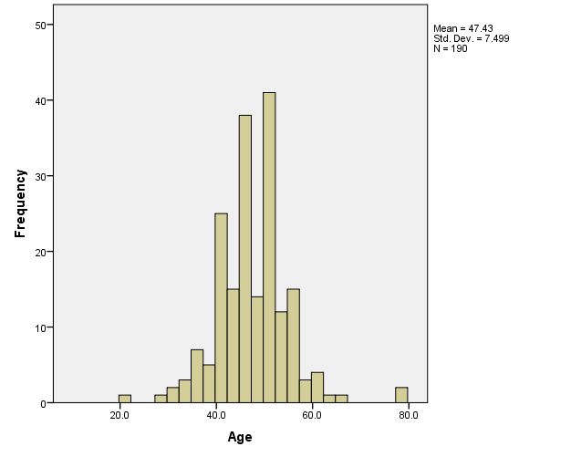

* 1. Delete the biggest outlier and redo part (a). What got affected more by the outlier, the mean or median (2 pt.)?

**Mean=47.093 Median= 47 SD=6.7869 Variance=46.062**

**The mean got affected more by the outlier. The mean changed when the outlier was pulled but the median did not.**

**I pulled out two outliers that were the same**

* 1. Redo part (d) but now, compare the guesses of Brother Cromar’s age between gender (In the Explore option in SPSS, put the Gender variable in the factor list box. You will get results for both genders). State in a sentence or two any differences between genders. (3 pts.)

**Not Pulling out the outliers**

**Women - Mean=48.023 Median= 47.5 SD=7.5468 Variance=56.955**

**Men - Mean=46.663 Median= 47 SD=7.4117 Variance=54.934**

**Pulling out the outliers**

**Women - Mean=47.433 Median= 47 SD=6.2646 Variance=39.246**

**Men - Mean=46.663 Median= 47 SD=7.4117 Variance=54.934**

**It appears that the mean and standard deviation is larger for women when no outliers are pulled. When outliers are pulled, the mean is larger for the women and standard deviation is larger for men.**